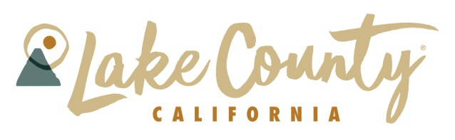
LAKE COUNTY TOURISM IMPROVEMENT DISTRICT (LCTID)
DBA Visit Lake County California www.lakecounty.com
Wednesday, July 9, 2025 – 12:00 Noon
Board Meeting - In Person
Skylark Shores Resort
1120 N. Main Street, Lakeport

AGENDA
All times indicated are approximate and subject to change. Subject to the discretion of the Chair, agenda items may be heard out of sequence. A roll call vote will be taken for action items. The public may speak for 3 minutes on any item appearing on the agenda when it is under discussion. Other topics may be addressed at the discretion of the Chair.

- Call to order; Introductions; Establish Quorum – Christie White 12:00 Noon

- Nominations/Elections: Directors – Christie White

- Financial Reports – Jeff Warrenburg
- Signatories for WestAmerica Bank Account – Confirm
- Credit Card

- Approval of LCTID Board Meeting Minutes for April 2, 2025 – Wilda Shock

- Short Term Rental Assessments – Patrick Sullivan, Lake County Treasurer-Tax Collector
Konocti Trails Website Relaunch – Ben Rickelman, Deputy County CAO
Gueno Valley Project Update – Josh Townsend and Kevin Case

- Executive Director – Brian Fisher
- Q2 Social Media Update and Website Analytics – GA4
- Book Direct Update
- Email Marketing Report
- Visit California
-More Than Just Parks, April 9/10
- North Coast Tourism Council Update
- LAKE Life 2025
-Magazine Release Party (July?)
-Certified Folder Display – Sonoma and Sacramento

- Public Comments/Member Comments/Announcements

- Adjournment 1:30 PM

NEXT MEETING: Wednesday, October 1, 2025, Noon-1:30 PM – Stein & Wein, Clearlake

Members: Christie White, Chair; Susan Parker, Vice Chair; Wilda Shock, Secretary; Jeff Warrenburg, Treasurer;
David Claffey, Priya Dias, Alan Flora, Larry Galupe.
Quorum is 5 members.

07/02/2025

